**Allow Existing Schedule Assignment**

***Preference Overview***

In the original schedule, there may be cases where two consecutive trips are assigned to a specific vehicle with overlap between them. It may be that the duration of the first trip is over estimated or if the second trip is expected to be delayed.

Normally, you would expect the optimization process to override and reschedule over- laped trips.

If however, such overlaps are deliberate, we can assign them a zero penalty. Otherwise, we define a non zero penalty in the usual way for not overriding them.

This preference allows you to maintain existing overlaps of consecutive trips



There are two preference templates available only one of which may be

used and then only as a single instance.

***Templates Available from Optibus***

*Table 1-1: Templates Summary*

|  |  |  |
| --- | --- | --- |
| **Template Name** | **Purpose** | **Reference** |
| Allow Existing Sched- ule Assignment by Route Group | Maintain existing overlaps of consecutive trips for a nominated Route Group. | **Allow Existing Sched- ule Assignment by Route Group** |
| Allow Existing Sched- ule Assignment | Maintain existing overlaps of consecutive trips | **Allow Existing Sched- ule Assignment** |

Maintain consecutive trips, for a nominated Route

Group.

**Prerequisites:** You should have already defined your route groups. See Miscellaneous

Assignments, **Route Groups**.



This template can only be used once, so you might need to set up a special

Route Group containing all of the routes needed for this purpose.

**Opening Dialog:**

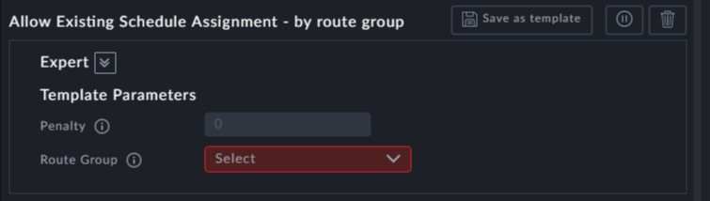

**Points to note:**

**Penalty**: The zero default penalty reflects allowing deliberate overlaps. A non zero penalty is imposed for maintaining existing overlaps.



**Route Group**: The **Route Group** field is mandatory



Maintain existing overlap consecutive trips-

**Prerequisites:** None.

**Opening Dialog:**

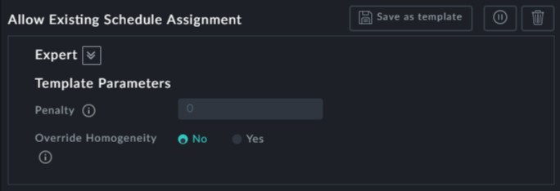

**Points to note:**

**Penalty**: The zero default penalty reflects allowing deliberate overlaps. A non zero penalty is imposed for maintaining existing non-deliberated overlaps.



**Override Homogeneity**: If this is set to Yes, then the new schedule will maintain con- secutive trips overriding any homogeneity conditions (see **Homogenic Vehicle Sched- ule**). This applies to any homogeity conditions already in force for the schedule or any that may be implemented after using this preference.

